

**Customer Service Scale**

1. Where do you think your business is operating at in these 5 levels of Customer Service?  
(Mark the relevant circle)

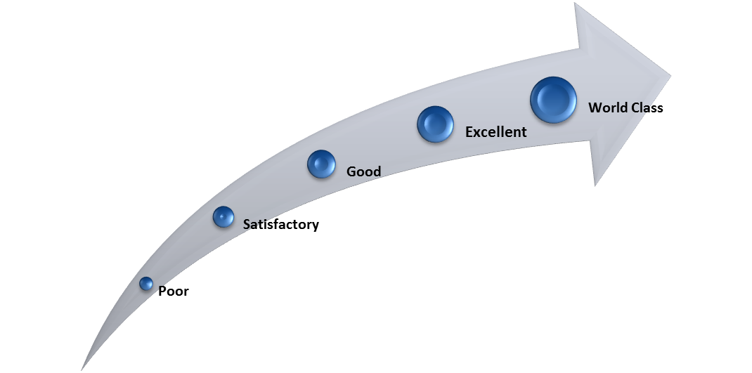

2. Explain why you think your company rates where it does?

________________________________________________________________________________________________________________________________________________________________________________________________________________________________________________________________________________________________________________________________________________________________________

3. What could you do to move futher up the scale?

________________________________________________________________________________________________________________________________________________________________________________________________________________________________________________________________________________________________________________________________________________________________________